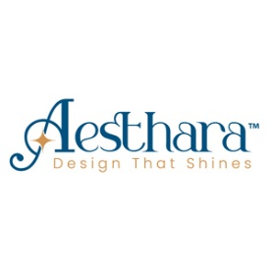

1st Page - Homepage Tab
- Hero Section with banner image:
Elevating Brands Through Visual Excellence

Transforming Ideas into Impactful Visual Stories

- Why Aesthara
Aesthara™ is an independent design and creative studio founded by Kawaljeet Singh, focused on building thoughtful, strategy-led brands and specializing in visual communication offerings such as graphic design, high-impact presentation design, and corporate branding.
Blending clarity with aesthetics, Aesthara collaborates with agencies, startups, and enterprises of all scales to build brands that are not only visually distinctive — but strategically aligned for long-term growth.
Every project is personally led and executed with precision, intention, and creative depth.
The approach is rooted in strategic thinking, refined execution, and a commitment to creating lasting brand impact.

- Our Design Services

In today’s fast-paced digital world,
great design isn’t optional - it’s essential. (to be highlighted in bigger font)

From developing compelling proposals and high-impact pitch decks to crafting comprehensive marketing collateral, we help businesses communicate with clarity and confidence.
Our experience spans multiple sectors, including financial services, global BPM, business consulting, IT, and AI-driven technology firms. We also excel in building cohesive brand identities, with a strong focus on healthy food and wellness startups.

- Presentation Design
How important is your next presentation to you?  It would change everything if you could just visually communicate better.  Creating effective, dynamic presentations that transform your brand, help you win more business and engage with your audience. | 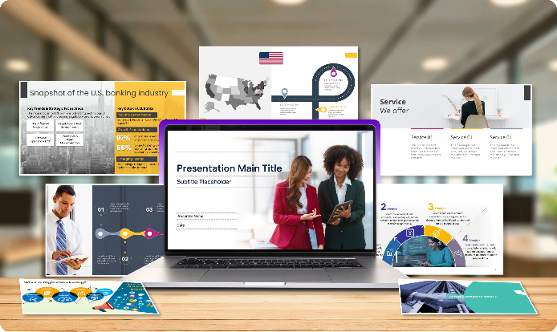
Custom templates & layouts, corporate and sales presentations, investor and pitch decks, infographics, and animated short videos — tailored to suit your brand’s visual identity.

- Graphic & Visual Design
A comprehensive range of creative solutions comprises the creative process of communicating ideas visually.  These services ensure clear messaging, strengthen brand presence, and enhance customer engagement. | 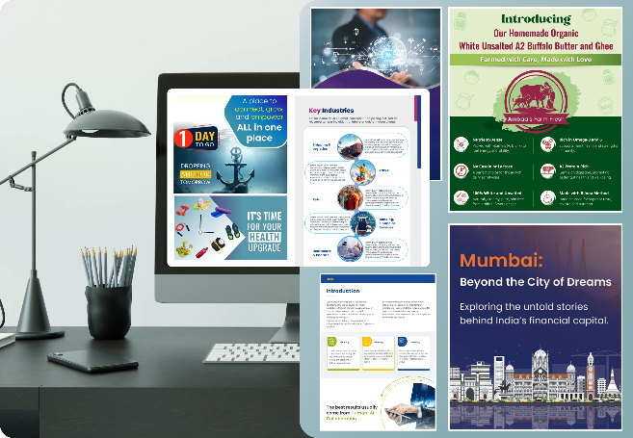
Marketing Assets: Flyers and Brochures, Whitepapers,
Case Studies, Standees, Poster and Blog/Article banners.

- Branding
Branding services cover a wide range of elements that help businesses establish a strong and consistent identity.  We cover majorly here, Visual & Marketing Assets, Logo Design, branding style guidelines, Color Palettes, Typography etc. | 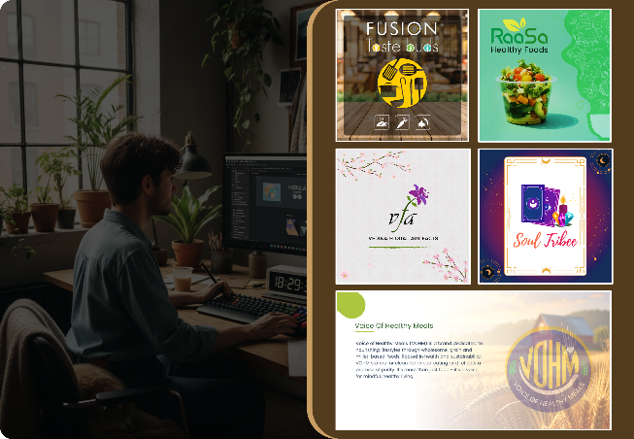
Brand’s Identity - logos design and color palettes, Typography, Imagery, Style Guidelines, Social Media Post & Ads

2000+  Slides Prepared | 105+  Presentations Designed | 7+  Clients Served | 100%  Service Excellence
60+
Marketing Assets and Branding Projects*
* Branding covers – logo design, brand style guidelines, social media posts and campaign ads

- Our Process

A four-step journey from insight to impact.
01. Discover | 02. Envision | 03. Deliver | 04. Evolve
Listen First | Shape Strategy | Impactful Design | Ongoing Growth
Understanding the brand, audience, and purpose. We listen before we design. | Shaping strategy, structure ideas, and creative approach. | Designing refined, impactful, ready-to-use outcomes. | Ongoing design partnerships, support, and feedback.

Trusted by Our Clients

Kawal has consistently demonstrated the ability to work quickly and efficiently. He comes with an impressive ability to grasp requirements at once. His delivery reflects careful attention to detail and a strong focus on producing excellent output. His proactiveness makes him a reliable partner for time-sensitive projects as well as those requiring high-quality design execution.
Jigesh Shah, Founder - RYVR Immersive 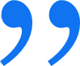
_______________________________________________________________________________________________
I had the opportunity to manage Kawaljeet at Anunta, and later collaborate with him as a freelancer. He is a dedicated and highly professional designer who combines clarity, creativity, and business understanding. He simplifies ideas without losing impact, protects brand guidelines, and consistently delivers exceptional work with impressive turnaround times. I fully endorse his creative and reliable expertise.
Ravi S Busi, Head of Marketing - Exponentia.ai 
_______________________________________________________________________________________________

I would like to appreciate the quality of work you have done for the deck. Thanks for the same.
Vivek Nirmal, CEO – KisanKonnect 
_______________________________________________________________________________________________
Hello,
I had started my insta page for my tarot journey and I wanted a very meaningful logo which should compliment the name of my page. Kawaljeet being my client offered to give it a try. And I must say he did a fabulous job. The logo is still there on my page. I haven’t thought of changing it. Thank you, Kawaljeet.
Anandita Tandon, Astrologist & Tarot Reader – Soul Tribee 
_______________________________________________________________________________________________

Your work for QuickTalent was a great document, and we still use some of its slides for the corporate presentation.
The deck was very creative.
Sindhu Girish, Manager – HR 
_______________________________________________________________________________________
Client logos:
Contact us form:
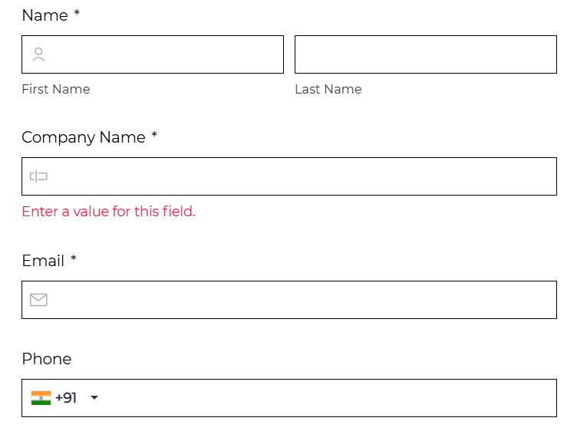
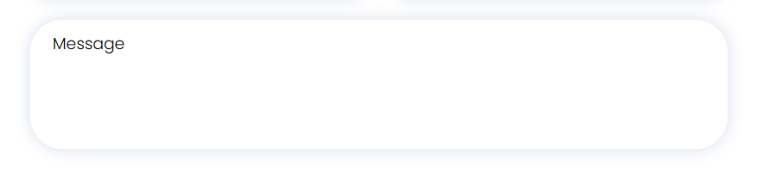
2nd Page - Portfolio Tab

Aesthara delivers tailored design and creative solutions across industries, partnering with marketing agencies, startups, entrepreneurs, and enterprise firms through project-based engagements, long-term retainers, and dedicated service models.
Sample images (to be shared)

Footer section to the bottom
Ready to make your brand stand out?
Let’s turn your vision into striking visuals.
Book a creative consultation today!
Aesthara © 2026 and Email / Contact link /Social Media
Mumbai | India
 LinkedIn: https://www.linkedin.com/company/aesthara-cs/
 Instagram https://www.instagram.com/aesthara_creative_solutions/
Privacy Policy

Resources (blog/case study)

References:
https://hypepresentations.com/services/
https://innoviousdesigns.com/
https://www.visualspiders.com/
https://pitchworx.com/
https://slidepeak.com/
https://brandemic.in/portfolio/
https://hypepresentations.com/pitch-deck-design-agency/
https://www.presentationmonk.com/

